CHAPTER 1
INTRODUCTION
Sixth Sense is defined as Extra Sensory Perception or in short ESP. It involves the reception of information not gained through any of the five senses. Nor is it taken from any experiences from the past or known. Sixth Sense aims to more seamlessly integrate online information and technology into everyday life. By making available information needed for decision-making beyond what we have access to with our five senses, it effectively gives users a sixth sense.
Sixth sense technology bridges the gap between real world and digital world. Physical object became part of this technology. The information around humans regarding touch, vision, taste, smell, hearing is perceived by using the five senses. But the most important information i.e. data which is available online through internet but it is restricted to interface or screen and is not naturally recognized by human senses, by eradicating the gap between digital world and the physical world such information will be readily available to the users.
The device is comprised of components such as camera, colour markers, mirrors connected wirelessly to the computing device. Camera recognizes individual image, pictures and gestures one make with their hand. Information sent to laptop for processing. The projector can project the information in any direction with the help of mirror.

1.1 Objective
The objective of this project is to create a sixth sense device which works on the principles of gesture recognition and image processing to capture, zoom (in and out), toggle pictures and control a robot with ease just by the help of coloured caps worn on the fingertips of the user and to connect the data in the digital world in to the real world.

1.2 Motivation
We’ve evolved over millions of years to sense the world around us. We use our five natural senses to perceive information around our surroundings. But the most useful information that can help us make the right decision is not naturally perceivable with our five senses, namely the data, information and knowledge that mankind has accumulated about everything and which is all available online. There is no link between our digital devices and our interactions with the physical world. Information is confined traditionally on paper or digitally on a screen. The key motivation of this project is to build a device which bridges this gap, bringing intangible digital information out into the tangible world, and allowing us to interact with this information via natural hand gestures.
1.3 Problem domain
Every one of us is aware of the five basic senses- seeing, feeling, smelling, tasting and hearing. These senses have evolved through millions of years. Whenever we encounter a new object our natural senses tries to analyse that experience and the information that is obtained is used to modify our interaction with the environment. But in this new age of technology the most important information that helps one to make right decision is something that cannot be perceived and analysed by our natural senses, that information is the data in the digital form, and it is available to everyone through sources like internet.
Although miniaturized versions of computers help us to connect to the digital world even while we are travelling there aren’t any device as of now which gives a direct link between the digital world and our physical interaction with the real world.
1.4 Solution to the problem
The sixth sense technology concept is an effort to connect this data in the digital world into the real world. According to Pranav Mistry the sixth sense technology has a view of human and machine interactions.
The sixth sense technology contains a pocket projector, a mirror and a camera in a pendant like wearable device. Both the projector camera and sensors are connected to a coding device (laptop) in the user’s pocket. The projector projects visual information enabling surfaces, walls and physical objects around us to be used as interfaces; while the camera recognizes and tracks users hand gestures and physical objects using computer vision based techniques.
1.5 Methodology
The software program in the sixth sense technology processes the video stream data capture by the camera and tracks the locations of the coloured markers at the tips of the user’s fingers. The movements and arrangements of these markers are interpreted into gestures that act as interaction instructions for the movement of robot.
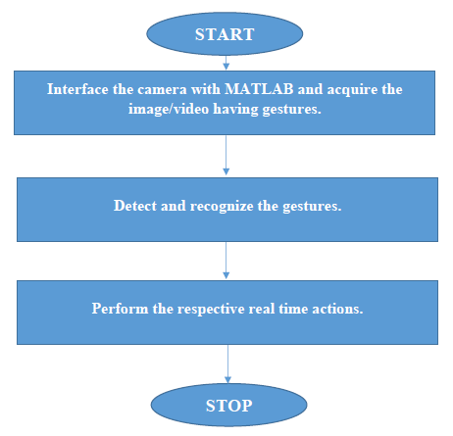
Figure 1.1: Work flow methodology

CHAPTER 2
LITERATURE SURVEY
[1] In the International journal “A Study on Sixth Sense Technology (ISSN 2229-5518)” the paper deals with the sixth sense device, a tool that connects the physical world with the digital world or the world of data. Here the database is used which will be initially trained for storage. With this model, the goal of the paper is to demonstrate, within a neurobiological framework, the ability of network that processes details of any person just by capturing the natural photographs. It implements the similar command which will gain access to the operation from the mobile device associated to it and projector is used for projection over any surface. Because of its cost constraint it is more likely to be implemented in future.
This paper focuses on to make us aware with the sixth sense technology which provides an integration of the digital world with the real world, it helps us to understand how the sixth sense device has overpowered the five natural senses, and it also pours light over its various applications and its security related issues. The recent trend in technology have revolutionised the means interaction between the digital world and real time applications. The primary focus of human computer interaction is to improve the intercommunication between user and computer by making computer more receptive to the user needs. Mouse too has undergone a significant revolution right from its invention, starting from a mechanical mouse to an optical mouse. In this paper they have implemented an invisible computer mouse that enables interaction with computer without attaching a hardware mouse. The methodology used is based on the sixth sense technology where the user will be able to move the cursor by the movement of fingers.
[2] In the International journal “A Step Towards Smart City Using Sixth Sense Technology (ISSN 2320-7345)” the paper reviews the evolution of Sixth Sense technology which later on developed into an Augmented Reality. The paper primarily focuses on the existing system and the proposed system. It also describes several participation platforms in which the open data projects include citizen or user competitions to develop app and other digital services to improve the quality and level of participation of public services. This is based on input from citizens obtained by providing ideation platforms to develop a better city, or competitions to take advantage of open public data to develop apps and useful new services.
The paper also reviews about the impact of Sixth Sense Technology in the IT and Electronics industry with the fact that it takes mobile computing to the next level. The paper reviews that the Sixth Sense Technology finds its approach in many ways. ICT (Information and Communication Technology) is a key enabler for cities to address these challenges in a smart manner. A smart city is one with at least one initiative addressing, one or more of the following six characteristics: Smart Governance, Smart People, Smart Living, Smart Mobility, Smart Economy and Smart Environment. They basically look at how a city has found a solution to the most pressing need of its people and turn it into an opportunity to improve lives, an official of the Union Urban Development Ministry says. The paper also proposes the idea of future work development i.e., the concept of intelligent traffic system. These are ICT enabled systems typically based on road sensors or active Global Positioning System .The objective is to monitor real time traffic information. The system will capture the traffic details via the camera placed at the junction and process it and as a result suitable real time actions will be taken. It might also take the feedback from the nearby camera or junction in order to manage city traffic in most efficient and environmentally friendly way possible.
[3] In the international journal “Drag & Drop: Data Transfer Between two Digital Devices (ISSN (O):2348-4470)” the literature review explores various approaches of transferring data between two different digital devices through which we can connect real physical world to digital world. These approaches are described as follows. There are many traditional hardware solutions for transferring data between digital devices such as Floppy Drive, Universal Serial Bus (USB) sticks, Hard disk drives etc. These all devices take long time & limited capacity and speed. So as a solution for this, the wireless methods like Bluetooth and infrared etc., are developed. The Put-that-there concept is a drag and drop controlled by the recognition of hand gestures and joystick operation. With the help of this interaction, any file or virtual object can be copied or moved to another location on the same screen. Pick and drop simulates the interaction of drag and drop to transfer digital information across multiple computer interfaces using a device similar to a pen stylus. In this design each pen has its unique Id which is readable from a computer when a pen is kept closer enough to screen. The Id’s are stored in a Cloud named as Pen Manager where the client is initiated for extracting the object. The Drag and drop operation using Sixth Sense Technology is described in which the information on the paper is copied to PC using coloured marked hand gestures. In this Technology they had used five components Camera, Smart phone, Projector, Mirror and Coloured Markers. The paper reviews about two different prototypes Slurp and Sparsh. Sparsh takes and interactive approach to transfer data through the idea conceptually. Slurp provides a Tangible User Interface (TUI) for extracting digital information from the physical objects and transfer them to the digital domain.These two prototypes work over the concept which allows a user to copy data from an Information Container in which the information is stored in the cloud under the camera device Id once another two devices are linked via the smart finger and drop/put it at the desired location in the computer.
[4] In the International journal "Design of Robotic Arm based on Hand Gesture Control System using Wireless Sensor Networks (IRJET)" which was published on March 2017, This paper focuses on design of hand gesture controlled robotic arm using microcontroller with the help of X-bee and wireless sensor networks. They used Robotic arm which is called as robot manipulator which can perform various functions as human arm performs. In industry or any application robot manipulator can be used for applications like welding, trimming; picking etc. advantage of such robotic arm is it can work in hazards area, which cannot be accessed by human.
This paper has implemented a system which consists of transmitter & receiver. Transmitter is nothing but human hand with flex sensors and receiver is robot manipulator. Motion of transmitter is wirelessly transmitted to receiver through X-bee module. Robotic arm which is receiver is nothing but a mechanical system formed by different joints and end to end effectors i.e. gripper movements of these fingers or gripper can be carried out using stepper motor or servo motor when user carry out motion of hand for any application at transmitter side same movement is copied by receiver as on transmitter, there are flex sensors mounted on glove at transmitter which change its resistance depending on movement of user.
The system transmitter consists of Microcontroller with two inputs from flex sensor and accelerometer. These flex sensors are mounted on human palm as user moves palm for particular applications flex sensor also bends by same amount as they are flexible. The transmitter side X-bee transmit the signal and this signal is received by the receiver X-bee and then fed to the microcontroller which drives motor through motor driver to control movement of robot manipulator. The sensor glove reads values from the flex sensors and correspondingly sends them wirelessly using X-bee protocol to the robotic hand. The operation is controlled with the help of Atmega16 development board by reading values from flex sensors. The flex sensors are mounted on each joint of all five fingers and bending of sensor due to hand movement of the operator changes the resistance of the sensor and this change in resistance is fed as input to the robotic unit. Implemented system used BO Motor to move robot manipulator gripper in forward and backward direction. It accepts DC voltage as input and converts it into train of pulses. This paper discussed hardware co-design of robotic arm controller using DC motors employing microcontroller ATMEGA16. Such type of hand gestures controlled robotic arm is mostly useful for Industrial, Medical and Military applications and used where the humans are unable to sustain in the difficult or harsh environments.
[5] In the International journal "MATLAB Based Gesture Controlled Robot (ISSN)”, published on January-March 2016, this review paper deals with the controlling of a robot/machine not with the old fashioned keys but with the natural interaction. The review paper utilises “Sixth-Sense technology” or the 6G technology i.e. using expression to convey the message. This technique involves controlling of robot using MATLAB programing.
This paper uses two types of interfaces:
- Human-PC interface: a person makes a different gestures using his hand which is captured by the web cam and PC processes this images using MATLAB. The processed images provide us the information about what the person wants to command through his gestures.
- PC-Robot interface: PC is connected wirelessly to the robot, the output generated by the PC is transmitted wirelessly through the Bluetooth module. In this case computer provide different directions to the robot for its traversal. This commands are transferred firstly to the microcontroller through the serial communication. Then further the command is transferred to the robot wirelessly.
The system involves acquisition of live streaming from the web cam for gesture recognition. The frames are taken at regular time interval. Here frame capturing rate for gesture is 2 frames per second.

CHAPTER 3
SYSTEM DESIGN

TRANSMITTER SIDE
RECEIVER SIDE

CAMERA
ROBOT MOTION

LAPTOP
MICRO CONTROLLER

WIRELESS COMMUNICATION
XBEE TX
Electrical to EM energy conversion
XBEE RX
EM to Electrical energy conversion

Figure 3.1: Functional Modelling analysis of the entire system

Working Principle
The above proposed system, using which the user can navigate the wireless robot in the environment using various gestures commands. In this system, user operates the robot from a control station that can be a laptop or a PC with a good quality in-built or external camera.
This approach works in a continuous manner where camera takes the live video, sending to the laptop and MATLAB installed in laptop processes the input and recognizes the colours at the fingertips of the users.
Camera takes the video and starts recording the live video and in continuation of recording it sends the live video to MATLAB which is installed in the laptop which is further connected with the camera. In MATLAB, code is prepared which convert the incoming live video from camera into frames of images or slicing of video is done in the form of images. These images that are obtained from the slicing of video are the processed for colour recognition process. The output of the colour recognition process are the images that contains the average value of those colours of which colour caps are present at the fingertips of the user.
From the obtained output image object is formed which further act as our input commands to control the robot motion. These commands are now send to the PIC Microcontroller wirelessly via a pair of zigbee module, of which one zigbee acts as a transmitter zigbee which transmits these commands which is then received by a receiver zigbee. The receiver zigbee then send these commands to the microcontroller which can control the motion of our robot using these commands.
The program dumped on the microcontroller is used to drive the DC motor which in- turn control the motion of the robot. Irrespective of the gesture technique used, robot is moved in all possible direction in the environment using four types of commands which are forward, backward, left and right.

CHAPTER 4
SYSTEM HARDWARE DESCRIPTION

  - PIC18F45K22 Microcontroller
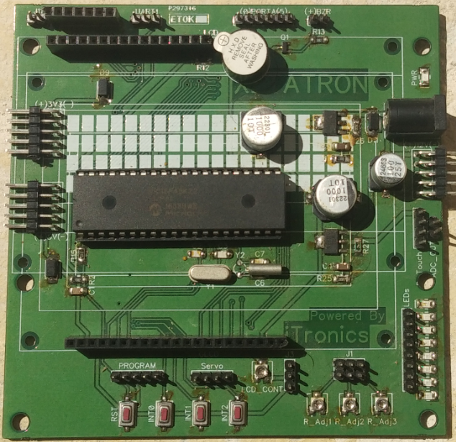
PIC (Peripheral Interface Controller) is a family of microcontrollers made by Microchip Technology. The first parts of the family were available in 1976; by 2013 the company had shipped more than twelve billion individual parts, used in a wide variety of embedded systems. The manufacturer supplies computer software for development known as MPLAB and PIC Kit series. Here we are using the microcontroller PIC18F45K22 and MPLAB as the programming environment.
Figure 4.1:PIC18F45K22 Development board
Some of the features of PIC18F45K22 are:
- High Performance RISC CPU.
- Upto 1024 bytes of EEPROM.
- 64KB Linear program memory addressing.
- Upto 16 MIPS (Million Instructions per seconds).
- Available in 28, 40 and 44-Pin DIP
- 10-bit ADC upto 30 external channel
- Three 8-bit Timers/Counters
- Four 16-bit Timer/Counter
- 2 PWM Channels
- In System Programmer (ISP)
- Serial USART
- SPI Interface
- Digital to Analog Comparator.
4.1.1 I/O Ports:
PIC 18F4522 has five 8-bit input-output ports.
4.1.2 Internal Calibrated Oscillator
- 16 MHz Internal Oscillator
- Four Crystal modes up to 64 MHz
- Two External Clock modes up to 64 MHz
- Secondary Oscillator using Timer1 at 32 kHz

    - Analog Features
- Analog-to-Digital Converter (ADC) module of 10-bit resolution, up to 30 external channels.
- Digital-to-Analog Converter (DAC) module of Fixed Voltage Reference (FVR) with 1.024V, 2.048V and 4.096V output levels.
- 5-bit rail-to-rail resistive DAC with positive and negative reference selection.
    - Timers/Counters
PIC18F45K22 consists of three 8-bit and four 16-bit timer/counter.
- Watchdog Timer:
– Watchdog timer is present with internal oscillator. Watchdog timer continuously monitors and resets the controller if the code gets stuck at any execution action for more than a defined time interval.

    - Interrupts:
- PIC18F45K22 consists of multiple interrupt sources out of which four are external. The remaining are internal interrupts which support the peripherals like USART, ADC, Timers, etc.
    - USART:
- It is available for interfacing with external device capable of communicating serially (data transmission bit by bit).
    - General Purpose Registers:
- Atmega16 is equipped with 32 general purpose registers which are coupled directly with the Arithmetic Logical Unit (ALU) of CPU.

    - Memory: PIC18F45K22 consist of three different memory sections:
- Flash EEPROM:
- Flash EEPROM or simple flash memory is used to store the program dumped or burnt by the user on to the microcontroller.
- It can be easily erased electrically as a single unit.
- Flash memory is non-volatile i.e., it retains the program even if the power is cut-off.
- PIC18F45K22 is available with 32KB of in system programmable Flash EEPROM.
- Byte Addressable EEPROM:
- This is also a non-volatile memory used to store data like values of certain variables.
- PIC18F45K22 has 256 bytes of EEPROM, this memory can be useful for storing the lock code if we are designing an application like electronic door lock.
- SRAM:
- Static Random Access Memory, this is the volatile memory of microcontroller i.e., data is lost as soon as power is turned off.
- PIC18F45K22 is equipped with 1536 of internal SRAM.
- A small portion of SRAM is set aside for general purpose registers used by CPU and some for the peripheral subsystems of the microcontroller.
- SPI: (Serial Peripheral Interface)
    - SPI port is used for serial communication between two devices on a common clock source. The data transmission rate of SPI is more than that of USART.

  - Motor Driver: L293D IC
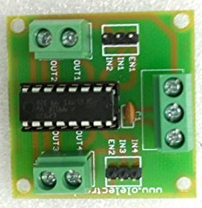

Figure 4.2: Motor driver L293D
L293D is a typical Motor driver IC which allows DC motor to drive on either direction. L293D is a 16-pin IC which can control a set of two DC motors simultaneously in any direction. It has a dual H-bridge Motor driver integrated circuit. The L293D can drive small and quite big motors. Since the output voltage of microcontroller is not sufficient to drive a motor so it is used to power the motor with the control commands coming from microcontroller. It has four input pins two on each side of the IC. All these four pins are connected to the digital pins of microcontroller and four output pins are connected to DC motor of the robot.

  - DC Motor
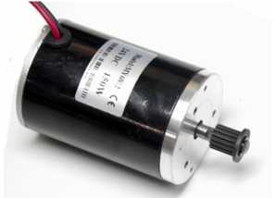

Figure 4.3: DC Motor

A DC motor is mechanically computed electric motor powered from direct current (DC). The current in the rotor is switched by the commutator. DC motors better suited for equipment ranging from 12V DC systems in automobiles to conveyor motors, both which require fine speed control for a range of speeds above and below the rated speeds. The two DC motors, each having specifications 12V, 60 RPM and 0.37 amps are used for the robot motion.

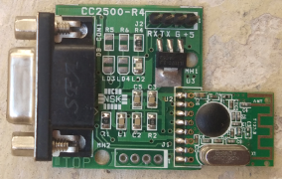
  - Zigbee Module

Figure 4.4: Zigbee module

Zigbee is an IEEE 802.15.4 based specification for a suite of a high level communication protocols used to create personal area networks with a small, low power digital radios. The technology defined by the zigbee specification is intended to be simpler and less expensive than other wireless personal area networks. Its low power consumption limits transmission distances to 10-100 meters line of sight, depending on the power output and environmental characteristics. The data transmission rate of the zigbee used ranges from (20-250) Kbits/sec and it globally operates on a single frequency of 2.4 GHz. Zigbee are popular wireless transceivers for a number of reasons. They are flexible-they send and receive the data over a serial port.

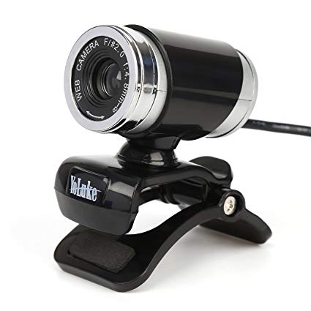
  - Camera

Figure 4.5: Camera
Camera is used to capture the object which is in the range and follow the users hand gestures. It grabs the motion of the coloured markers worn on the fingertips and tracks the users hand gestures. The camera recognizes individuals, images, gestures that user makes with his hand and then sends this data to the laptop or PC for processing. The camera performs a basic interface device between laptop and the physical world. It acts as a digital eye connecting the user to the digital world.

  - Laptop or personal computer
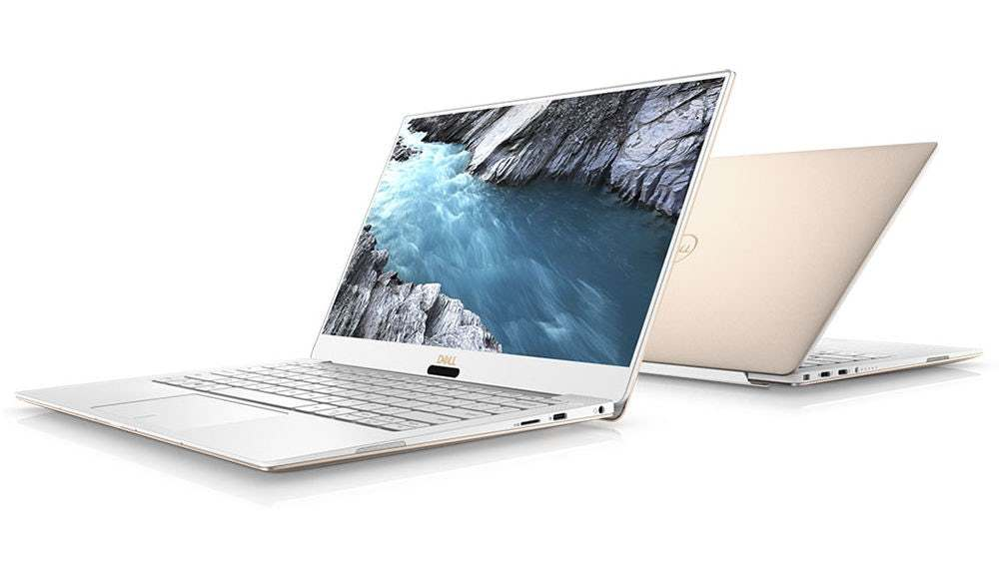

Figure 4.6: Laptop
A laptop with web enabled services is used as the processing device that processes the input video data send by the camera. It is also used for running or implementing the code written on the MATLAB tools for executing the concept of image processing. The various gestures done by the colour marker are tracked by the camera and hence given to the laptop for further processing of the various applications involved.

  - Coloured Markers
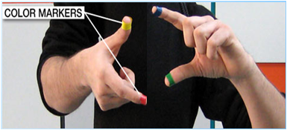

Figure 4.7: Coloured Markers

These coloured markers placed at the fingertips of the users. Making the user’s fingers with red, yellow, green and blue coloured tape helps the webcam to recognize the hand gestures. The movements and arrangements of these markers are grasped as gestures that act as an interaction or projected application interfaces.

Chapter 5
SYSTEM SOFTWARE DESCRIPTION
The software’s used for the development of the system are:
- MATLAB
- mikroC PRO

  - MATLAB
MATLAB is a high-performance language for technical computing. It integrates computation, visualization, and programming in an easy-to-use environment where problems and solutions are expressed in familiar mathematical notation. MATLAB has evolved over a period of years with input from many users. In university environments, it is the standard instructional tool for introductory and advanced courses in mathematics, engineering, and science. In industry, MATLAB is the tool of choice for high-productivity research, development, and analysis.
We used MATLAB version 2015a in our project as Image Processing Toolbox which provides a comprehensive set of reference-standard algorithms and workflow apps for image processing. Image acquisition, Image segmentation, enhancement, noise reduction, geometric transformation, etc, can easily be performed using MATLAB. Acquiring and Importing images and videos generated by a wide range of devices including webcams, digital cameras, etc. are done with MATLAB.
  - mikroC PRO
MikroC Pro for PIC is a powerful, feature rich compiler for PIC microcontrollers from Mikroelektronika. It is easy to learn and easy to use with a highly advanced integrated development environment (IDE), ANSI complaint compiler, broad set of easy to use hardware and software libraries. It is the best solution for developing code for PIC devices. It features intuitive IDE, powerful compiler with advanced optimization, lots of hardware and software libraries and additional tools that helps in the completion of our work.

Chapter 6
SYSTEM IMPLEMENTATION

Camera

Capturing gestures movement
Extracting colours from the markers
Object detection

Command detection using specified method
Image Processing at control Station

Micro controller
Zigbee module

Motor driver
Robot motion

Figure 6.1: Control flow block diagram
  - Acquiring Image
The general aim of image acquisition is to transform an optical image (Real World Image) into an array of numerical data which is later manipulated on a computer, before any video or image processing can commence an image must be captured by camera and converted into digital form.
The image acquisition process consists of 3 steps:
- Optical system which focuses the energy
- Energy reflected from the object of interest
- A sensor which measure the amount of energy

Image Acquisition is achieved by a suitable camera. The real time video is given by the user by making different gestures. The video is sliced into images at a particular frame rate of 30 fps. One frame is picked at random for further processing. In order to obtain the intensity information the acquired image is converted into grayscale image.

  - RGB to Gray scale conversion
A grayscale digital image is an image in which the value of each pixel is a single sample that is it carries only intensity information. As compared to coloured image, computational complexity is reduced in a grayscale image.
In order to perform the conversion from RGB to gray scale we use two methods they are:
- Average method
- Weighted method
In average method we take the average of the three colours RGB that is:
Grayscale= (R+G+B)/3
Since three different colours have three different wavelengths and have their own contribution in the formation of image so we have to take the average according to their contribution which is overcome by the weighted average method.
In the weighted average method we multiply the rows, columns and three RGB layers of an image (R*C*B) to get a gray scale. The gray scale has a 255 different shades. Hence it will have 255 bits of image size. According to the sensitivity of the eye the colors are multiplied with their sensitivity level and added to get the gray scale image. For example if green color has higher sensitivity hence higher wavelength of 59% (0.59), in the same way red has 30% (0.3) and blue has 11% (0.11) then,
New gray scale= (0.3*R)+(0.59*G)+(0.11*B)
The above formula gives the conversion from RGB to gray scale where RGB are the wavelength of RGB of an image to be converted.

  - Extraction of Colour
After converting the image to a grayscale image the required colour is extracted such as green, red or blue. The colour which we want to extract from the original image, the layer of that colour was removed and an average image of remaining two colors are formed. For example if we want to extract green colour then layer of green colour is removed from the original image and average value of resultant image is formed which contains the average of red and blue colour.
Now the grayscale image obtained in previous step was subtracted from the above averaged image to get an image consisting of only average value of that colour which we need to extract from the original image (green).

  - Gray to Binary Scale Conversion
In order to convert from gray scale to binary we use thresholding method. In this method we select a threshold value from the image formed in the previous step in such a way that all the gray level value which is below the selected threshold value is classified as 0 (black i.e., background) and all the gray level which is equal to or greater than the threshold value is classified as 1 (white i.e., foreground).
Now using that threshold value the image obtained in previous step is converted to binary image, this output binary image has two values 0 and 1 and we specify the levels of the image in the range of [0, 1]. The output image is a black and white image and the white part of the image represents the marker from our finger.

  - Finding Centroid of an Image
Next step is to find the centroid of the white object. For the user to control the mouse pointer it is necessary to determine a point whose coordinates can be sent to the cursor. With these coordinates the system can perform robotic movements.
The object that is formed is sometimes or most of the times is of irregular shape. So to find the centroid we have to go to the properties such as area, center of mass, orientation and bounding box. To calculate these properties we use image analyzer app “regionprops” which functions in MATLAB. Then the centroid is calculated for the detected region. The output of function is a matrix consisting X and Y coordinates of the centroid.

  - Serial Communication between MATLAB and Microcontroller
PIC Microcontroller which has enabled serial communication is used to program the robot as per the requirement. The overall movement of a robot is controlled by the motors used. These motors are attached to the wheels of the robot and are programmed for moving forward, backward, turning left and turning right by giving a certain command. These commands are send to the microcontroller by serial data communication which is fed to the motor driver IC L293D which further drives the motor as per the requirements.
The number of centroid is transmitted to zigbee coordinator via COM port of the system. Zigbee router present in wireless network receives data coordinator and it transmits to the microcontroller.
The marker act as a command to drive the robot in the forward, backward, turning left and turning right. Initially a command from the keyboard is send by serial data communication to drive the motor but now these colour markers act as a virtual keyboard and are used to send the command to the robot through zigbee module via wireless communication. If there are two markers in the fingers, that will behave as two object in the output screen of MATLAB. So using multiple colour we can make multiple objects in the output screen and can perform multiple task by the robot. So now with the help of these markers we can control the movement of our robot because now these markers will act as different commands which are sent by serial communication for robotic motion.

CHAPTER 7
RESULTS
  - Snapshot
The below figure is the snapshot of our project model. It indicates the overall interfacing of different hardware components used in our project. This model is controlled using the objects that are created using image processing techniques. Those objects act as a commands which is transmitted through a transmitter zigbee connected to the laptop and is received by a receiver zigbee connected to the microcontroller as shown below.

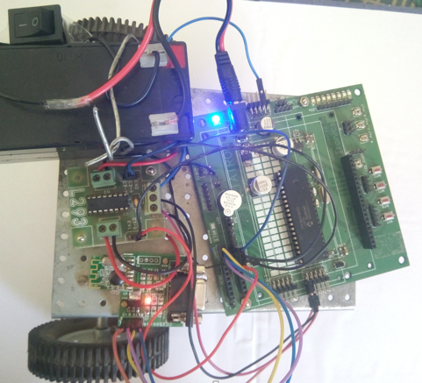

Figure 7.1: Snapshot of working model

  - Algorithm to get the Results
Step 1: Acquiring Image from Camera.
Step 2: Converting RGB to Grayscale image.
Step 3: Extracting the required colour from the original image.
Step 4: Setting threshold for the extracted image.
Step 5: Converting grayscale image to binary image.
Step 6: Setting centroid for the binary image to get the object.
Step 7: Transmitting the obtained object wirelessly through a zigbee module to the microcontroller.
Step 8: Microcontroller controls the movement of the robot
- If one object is detected, robot moves in forward direction.
- If two objects are detected, robot moves in backward direction.
- If three objects are detected, robot moves in left direction.
- If four objects are detected, robot moves in right direction.
- If no object is detected, robot stops.

  - Object Extraction results
Object is extracted by the step by step procedure as discussed in the system implementation part. The result that we obtain from the object extraction is shown in the below figure.

- Acquired Image
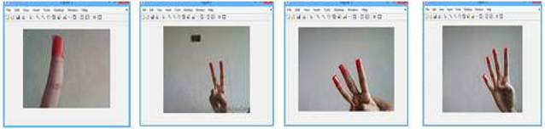

Figure 7.2.1: Acquired Image

- RGB to Grayscale Conversion
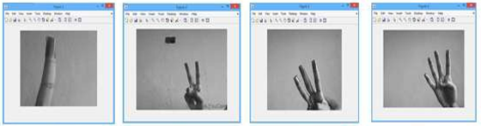

Figure 7.2.2: RGB to Grayscale Conversion

- Colour Extraction
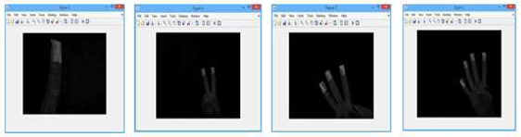

Figure 7.2.3: Colour Extraction

- Converting Grayscale image to Binary image and setting centroid to obtain Object.
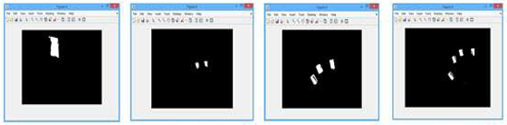

Figure 7.2.4: Required Binary Image

  - Command detection
Object that are extracted from different gestures made by the users hand act as a command to run the robot. These commands are transmitted serially through wireless communication medium with the help of zigbee module to trigger the microcontroller. Different commands or objects made by users can make the robot to move in different directions. Logic for objects which are converted to robotic motions are as follows:
OBJECT DETECTED | ROBOT MOTIONS
No Object | Stops
One Object | Forward
Two Objects | Backward
Three Objects | Left turn
Four Objects | Right turn

Table 7.1: Object-directions relationship

CHAPTER 8
APPLICATIONS
This Sixth Sense prototype implements several applications that demonstrate the usefulness, viability and flexibility of the system.
Some of the useful applications of our project are listed below:
- Defence- It is used as surveillance robot so that they can help the force with the location or to spy on their enemies. Since they are small, easy to carry and can reach inconvenient places.
- Wheel chairs- Gesture based wheel chairs can be used for the differently- abled persons so that they do not require dependency of others.
- Domestic- Various home appliances can be controlled through gestures without needing any switch socket for the operation. Also the gestures controlled systems are used for the entertaining purposes like play stations, 3D games, etc.
- Medical environment- Touchless interfaces are of great necessity in various medical fields, patient monitoring and also for surveillance.
- Industries- Various heavy machines like trollies, arms etc. can be controlled with the help of gestures. Basically, automated devices which can be controlled through gestures using programming can be installed. The approach has huge potential to carry out work in various other fields. With the help of better specifications of the microcontroller the work can be updated and also the performance of the system can be improved. Use of better wireless communication technique can improve the system work.
- Automobiles- Gesture controlled access to vehicles will surely decrease the problems while parking or getting access to your vehicle via this technology if the vehicle gets stuck.

CHAPTER 9
ADVANTAGES AND DISADVANTAGES
9.1 Advantages:
- One of the main advantage of this sixth sense device is its small size and portability. It can be easily carried around without any difficulty.
- The cost incurred for the construction of the sixth sense prototype is quite low. It was made from parts collected together from common devices.
- Forming a connection between the real world and the digital world was the main aim of the sixth sense technology.
- The data access through recognition of hand gestures is much easier and user friendly to the text user interface or graphical user interface which requires keyboard or mouse.
9.2 Disadvantages:
- It will undoubtedly lead to a technology addiction. Excessive use of technology had already been affecting social lives. With this there is going to be a reduction in social nature of the world.
- Night vision mode camera has to be used in darker regions, this might make this technology quite expensive.
- Coloured finger caps has to be used for creating an object.

CHAPTER 10
CONCLUSION
This gesture controlled robot make use of gestures made by users hand which in turn acts as an object to control the motion of robot in this way it helps us to connect us with physical world around us. Since gesture control being a more natural way of controlling the devices makes the control of robots in more efficient and easier manner.
The key here is that this prototype recognizes the objects around us, displaying information automatically and letting us access it in any way we want, in the simplest way possible. Clearly, this has the potential of becoming the ultimate “transparent” user interface for accessing information about everything around us. This gesture controlled robot system gives an alternate way of controlling robots. Gesture control being a more natural way of controlling the devices makes the control of robots more efficient and easy.
So from the discussions so far it is not hard to insinuate the remarkable scope of sixth sense technology. It has the potential to completely change man’s perspective about real objects and there will be a thin and narrow line between our real world and the virtual world. It will make our world easily accessible by introducing the digital world into it.

CHAPTER 11
FUTURE ENHANCEMENTS
The Gesture Controlled robot designed in this work has many future scope. The robot can be used for surveillance purpose. The robot can be applied in a wheelchair where the wheelchair can be driven by the movements of riders’ hand. Wi-Fi can be used for communication instead of zigbee to access it from a greater distance. Edge sensors can be incorporated to it to prevent the robot from falling from any surface. Some camera can be installed which can record and send data to the nearly computer or cell-phone. It can be implemented on a watch, or in any home appliances like Room heater.
This technology can be enhanced to work in the military surveillance where it can be sent to some enemy camps and tracks its activities via internet. Useful for people who can’t speak and can make possible to understand by others what he try to say with his sign movements’ recognition into text. Security to this technology can further be improved and more accuracy should be aimed for. Surgeons of the future might use a system that recognizes hand gestures as commands to control a robotic scrub nurse or tell a computer to display medical images of the patient during an operation. With a mind full of creation, the possibilities are endless.

CHAPTER 12
REFERENCES
- Shailaja Udtewar, Joesh J. Noronha, Yash A. Chheda, “Advanced AR-Augmented Reality using Sixth Sense Technology” International Journal of Engineering Science and Computing, volume: 6 Issue: 5, May 2016.
- D.S. Patil, Shahak Patil, “Sixth Sense Technology-A new Innovation” International Journal on Recent and Innovation Trends in Computing and Communication, volume: 2, Issue: 5, May 2014.
- Sidharth Rajeev, “Seventh Sense Technology”, 2015 IEEE UP Section conference on Electrical Computer an Electronics (UPCON).
- A. Sumithra, K.karthika, J. Jane Ida, “A Step towards Smart city using Sixth Sense Technology”, International Journal of Research in Computer Applications and Robotics, volume: 3, Issue: 9, September 2015.
- Akhilesh Waoo, Subhashish Das, “Empowerment of Digital World using Sixth Sense Technology”, American Association for Science and Technology (AASCIT), volume: 4, Issue: 6, August 2017.
- Vishmita Yashwant Shetty, Vinayak Bhupendra Rai, “Sixth Sense Technology”, International Journal of Science and Research (IJSR), volume: 3, Issue: 12, December 2012.
- R.Raja Prabhu, R.Sree Vidya, “Design of Robotic Arm based on Hand Gesture Control System Using Wireless Sensor Networks”, International Research Journal of Engineering and Technology (IRJET), volume: 04, Issue: 03, March 2017.
- Mukti Yadav, Mrinal Yadav, Hemant Sapra, “MATLAB based Gesture Controlled Robot”, Journal of Basic and Applied Engineering Research, volume: 3, Issue: 02, January-March 2016.

